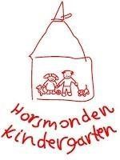
HORSMONDEN KINDERGARTEN
PROSPECTUS 2018
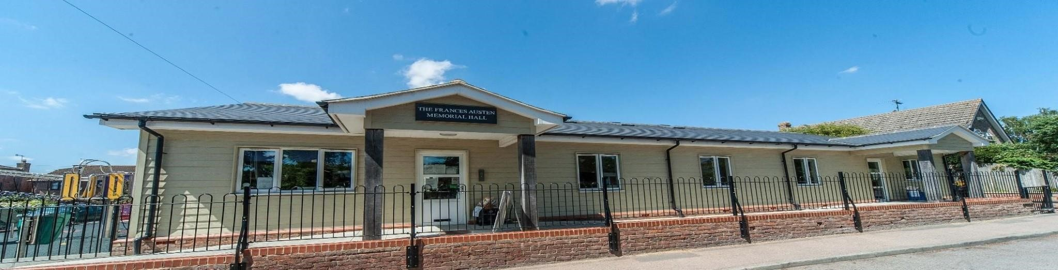

Frances Austin Memorial Hall, Back Lane, Horsmonden, Kent, TN12 8NJ Telephone: 01892 724805
Email: info@horsmondenkindergarten.co.uk Website: Horsmondenkindergarten.co.uk
Registered as a Charitable Incorporated Organisation in England and Wales
Registered Charity Number: 1168296 Ofsted Registration Number: EY546431 Established in 1980 Registered

ABOUT US
Horsmonden Kindergarten is a non-profit making preschool welcoming children from the age of 2 years until they reach school age. We were established in 1980 and are situated in a thriving rural village just a short walk from the local Horsmonden Primary School.
Horsmonden Kindergarten aims to provide a caring, secure, stimulating and happy environment where children learn to interact with other children and adults. Interesting and diverse play activities help them learn to make friends, develop social skills and enable them to achieve their full potential. We feel that when children are relaxed, safe, valued and having fun it builds their confidence and develops independence, making them happier to learn and of course paving the way for their move to school.
Our Kindergarten is regularly inspected by Ofsted and in 2016 we were awarded ‘Outstanding’ in all areas. This shows that we have maintained our high quality standard of care since the previous ‘Outstanding’ awarded in 2009. A quote from the report states: “Staff meticulously assess and monitor children’s progress and regularly share ideas for developing the next steps in learning with parents.
This helps parents to support learning well at home”.
In 2014 Horsmonden Kindergarten also attained the Kent Quality Mark (KQM) which is a Kent County Council inspired quality assurance scheme designed to encourage nurseries and preschools to raise their standards even higher. The KQM project focused on how to challenge and stimulate physical development and continues to benefit all of our preschool children.
Our organization is a Registered Charity, a member of the Preschool Learning Alliance and a registered preschool with Kent County Council offering Government funded places.
Our prospectus provides information about the running of Horsmonden Kindergarten and allows you to make the right choice when deciding on a preschool for your child. Our purpose built premises with outside space enhances a very special and welcoming facility and we hope you will come and visit to see for yourselves!!

LEARNING AT KINDERGARTEN
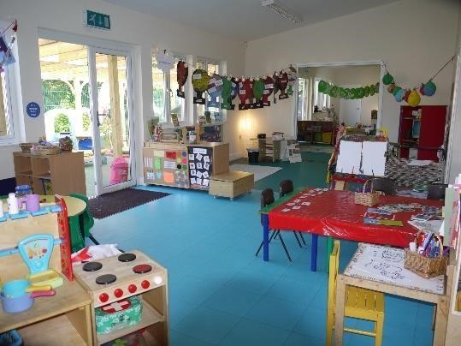
Since February 2009 the Kindergarten has operated from a building which was designed and built specifically for our preschool children. This spaciously designed facility, with two interconnecting classrooms, offers a large internal area with natural lighting where different activities are set up daily. Outside we have a dedicated enclosed play area with artificial soft surface. Since February 2015 a large proportion of this space has been covered by a canopy offering outdoor play whatever the weather. We are also lucky to be linked to the well-equipped village playground and a grass recreation ground. There is plenty of opportunity for the children to let off steam and be adventurous!
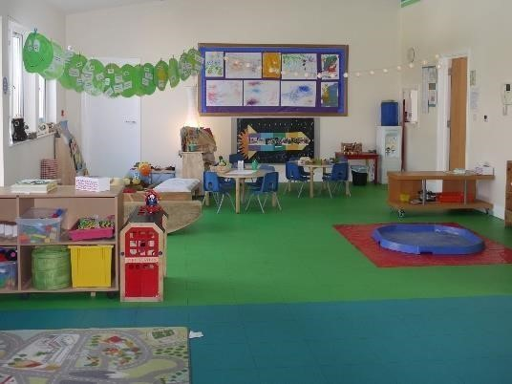
Horsmonden Kindergarten does not only provide a safe environment for children to play and interact but we also offer a setting where children can learn and develop. We support all children through their early years’ development to prepare them for the transfer into primary school. At Horsmonden Kindergarten the staff implement the Early Year Foundation Stage (EYFS) framework which is a government framework showing staff how to create well-planned play-based approaches to learning and development. Further information about the EYFS framework can be found on the website (online at: www.foundationyears.org.uk/eyfs-statutory-framework/).
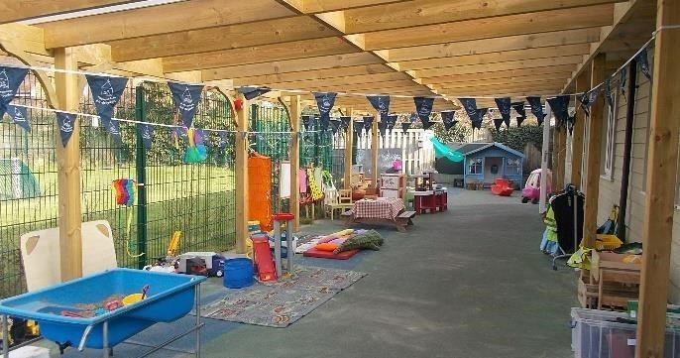
Horsmonden Kindergarten also organizes many other events including Sports Days, Nativity Plays as well as Christmas and Easter end of term parties. Children can participate in various activities throughout the year. Previous years’ activities have included a visit to the local fire station, the observation of eggs hatching into chicks during the period leading up to Easter and involvement in physical exercise sessions using the primary school hall. All these events add to the development of confident children who will move on to Primary School ready to benefit fully from the opportunities ahead.

STAFF
The day to day running of Kindergarten is managed by Co-Supervisors Tina Walker and Sarah Russell. We have a team of eight other staff who work a variety of sessions throughout the week. At Horsmonden Kindergarten we adhere to the Ofsted adult to child ratio of 1:4 for 23 year olds and 1:8 for 3-5 year olds although we are frequently able to improve on these ratios.
Staff attend training courses to continue their professional development in Child Protection, Planning and all aspects of the Early Years Foundation Stage, First Aid, Food Safety, Autism, and Health & Safety. Staff who prepare and handle food also receive appropriate training and understand and comply with current food safety and hygiene regulations. All staff hold up-to-date certificates following criminal record checks undertaken by the Disclosure and Barring Service (DBS).
Our 2016 Ofsted report states “the quality of teaching is excellent. Staff place a strong focus on developing the provision. They are enthusiastic, highly reflective and exceptionally keen to improve outcomes for children.” Current Staff
- Sarah Russell – Level 3 - Co-supervisor and Special Educational Needs Coordinator (Senco)
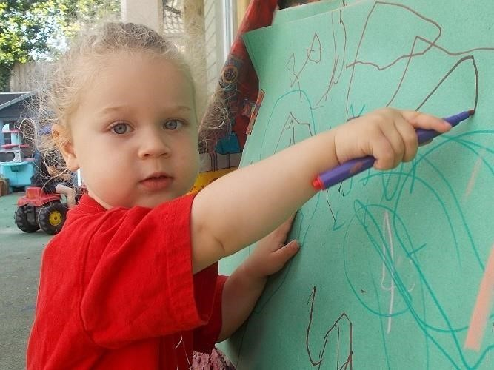
- Tina Walker – Level 6 - Co-supervisor and Early Years Designated Person for Safeguarding
- Sarah Shepherd – Level 3 - Deputy Supervisor and Health & Safety Officer
- Hayley Baldock – Level 4 - Qualified Childcare Practitioner and Deputy Senco
- Amy Histed- Level 3 – Qualified Childcare Practitioner
- Maxine Kervene - Level 3 - Qualified Childcare Practitioner
- Emma Everitt – Level 3 - Qualified Childcare Practitioner
- Claire Penfold- Currently working towards her Level 3 in Childcare
- Becky Painter - Administrator – Level 3 – Qualified Childcare Practitioner

KEY PERSON
We allocate a Key Person to each child when they start with us. We believe that a Key Person system helps children adapt to their time at
Kindergarten as the Key Person will oversee your children’s care as well as their emotional and physical well-being. Your child’s designated Key Person acts as a link between home and Kindergarten and will be able to address any queries or concerns that you may have. Record keeping is vital for planning for individual children and ensuring successful development. All records are confidential and accessible to parents at any time. We are firm advocates of working in partnership with parents to ensure consistency between your child’s care at home and at Kindergarten. It is important to have strong links with parents and therefore we encourage you to share any concerns with your child’s Key Person or any other member of the staff. A red file is compiled for every child which will serve as a lifetime reminder of their time at Horsmonden Kindergarten. In addition, ‘one to one’ parent meetings take place three times a year.
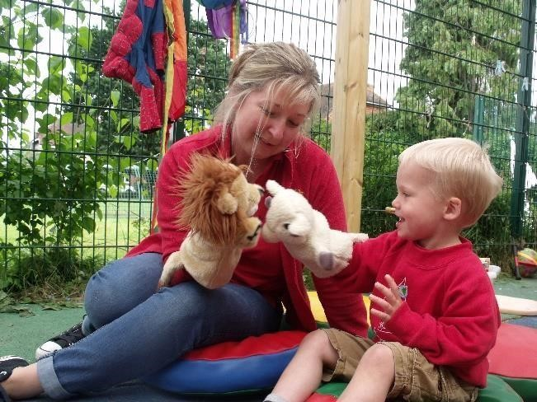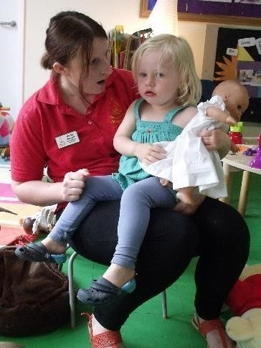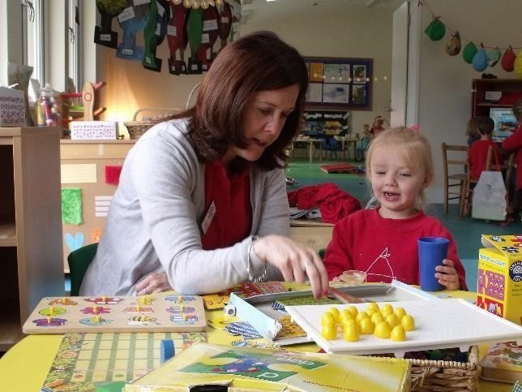

SESSIONS, CLASS STRUCTURE AND FEES
Children are eligible to attend Kindergarten once they are two years old. Horsmonden Kindergarten is open 8.30am – 3:30pm from Monday to Friday during term time and is open 38 weeks a year. Session times are very flexible according to what is best for you and your family and children can attend morning sessions (8.30am or 9am – 12am), afternoon sessions (1pm – 3.30pm) or full days (8.30am or 9am – 3.30pm).
Morning and afternoon sessions have the additional option of your child attending lunch club (12am – 1pm).
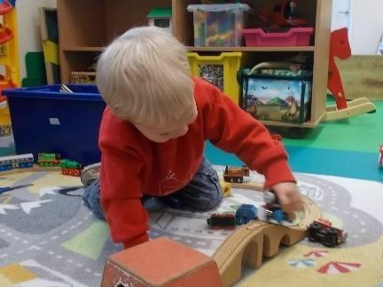
Caterpillars: These are children joining kindergarten at the age of 2 years until they reach the academic year prior to joining primary school reception class. Children in this class may be eligible for the Government Free For 2 (FF2) Scheme which offers 15 hours of free childcare - for eligibility please refer to the Government website. The term after the child turns 3 they become eligible for the Free Early Education Entitlement Scheme as described below. Children taking advantage of our facility for additional childcare (wrap-around cover) or where there is no FF2 entitlement will be charged at a rate of £4.95 per hour.
Butterflies: These are children that are the academic year prior to joining primary school. Children in this class can take advantage of the Free Early Education Entitlement (FEEE) Scheme offering up to 30 hours of free childcare under the Universal and Extended Entitlement for all parents using childcare in the term following their child’s third birthday. Please speak to our Administrator if you have any queries regarding funding entitlement. The parents of those children who receive early education entitlement for 2 year olds are encouraged to look into eligibility for Early Year Pupil Premium (EYPP). This is additional funding for early year’s settings used to improve the quality of education provided for disadvantaged 3 and 4 year olds. Children taking advantage of our facility for additional childcare (wrap-around cover) will be charged at a rate of £4.95 per hour.
All ad hoc sessions (butterflies or caterpillars) will be charged at £4.95 per hour. Ad hoc sessions can be booked where availability exists and at short notice if spaces are available. All fees are paid termly and can be paid directly through direct bank transfers, cheque or cash.
Please note that we also accept all childcare vouchers.
WHAT WILL YOUR CHILD NEED?
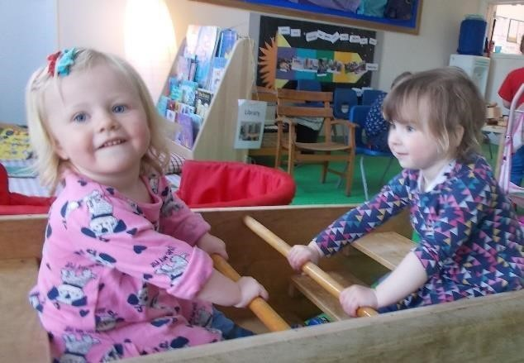
As part of our creative development activities children are encouraged to explore and experiment with all kinds of materials including messy ones so we recommend that all children are dressed in old clothes! We also recommend dressing your children in trousers that are easy to pull up so that physical independence can be developed. Children are encouraged to go outside every day so outdoor clothing, suitable for the weather, will be necessary. A full change of clothes should always be kept at Kindergarten as getting wet or muddy is highly probable! Horsmonden Kindergarten t. shirts and sweatshirts can be purchased, wearing these items contribute to your child’s sense of belonging but they are not compulsory.
If your child attends lunch club, you will need to provide a packed lunch which we encourage to be nutritious and healthy but due to allergies must not contain nuts. We operate a snack bar during the morning and afternoon sessions when a range of healthy snacks are provided and prepared by Kindergarten staff.

COMMUNICATION WITH PARENTS
There are white boards in the entrance foyer advising parents and carers about your child’s daily activities. Other notices are on display advertising various events and activities organized by the Kindergarten. A weekly newsletter is sent by email to all parents which details the previous week’s achievements and advises parents and carers of forthcoming events. In order to run effectively Horsmonden Kindergarten adheres to a number of policies which are available to all parents. We encourage parents to familiarize themselves with these policies which are kept on display in the entrance foyer. Electronic and paper copies can be provided on request. We also recommend that parents take time to look at the Preschool Learning Alliance website which offers valuable support and advice.
We have a website and Facebook page which we recommend all parents to read on a regular basis.

A TYPICAL DAY AT HORSMONDEN KINDERGARTEN
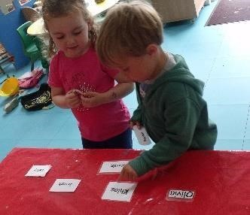
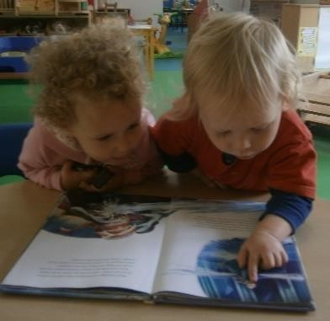
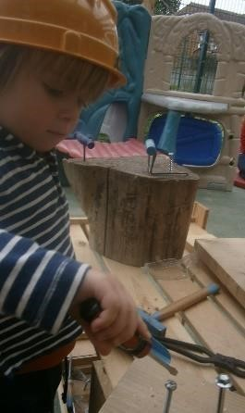
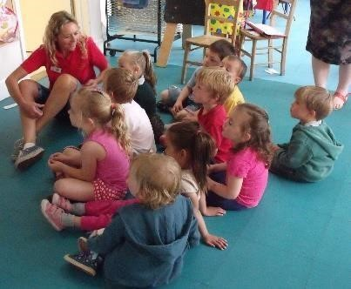
The children are welcomed into Kindergarten at 8.30am by a member of staff. They find their name badges and stick them on the wall. The rooms are set up prior to the children’s arrival with messy play activities, play dough and painting/drawing or cooking. The children can choose any activity or play outside where there are lots of ride on toys, a play house, climbing frame, sand pit and other outdoor activities.
At 10 the snack bar opens and children can choose from a variety of healthy snacks and have a drink of water.
At 11.30am the staff and children join together for circle time with ‘sound of the week’ show and tell. Sometimes they split into smaller groups for a more in depth discussion.
The morning session finishes with music and movement and the children join together to sing the goodbye song.
Lunch club runs from 12 until 1 where the children sit and enjoy their lunch together before play resumes. At 1pm the afternoon session begins and children are invited to choose an activity. Sometimes small groups may visit the park next door or the primary school during either the morning or afternoon sessions.
At 2pm the snack bar opens again to offer some healthy snacks.
At 3pm the children settle down for circle time and show and tell before joining together for the goodbye song and being collected at 3.30pm.

COMMITTEE AND FUNDRAISING
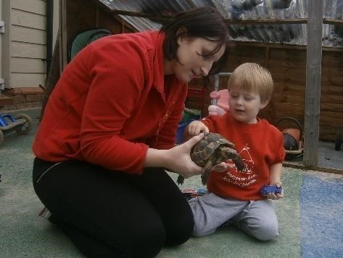
Horsmonden Kindergarten is a non-profit making organization which is run by an elected committee of volunteers. This elected management committee is composed of current parents/carers and members of the local community. This Committee, in consultation with staff, is responsible for all major decision making including reviewing policy and practice, managing finances, planning for building maintenance and overseeing the employment and appraisal of staff members. Committee meetings occur each month to plan fundraising events, keep track of finances, and keep up to date with new developments. The Annual General Meeting is held in the autumn and provides an opportunity for the Committee to provide all parents and carers with the financial and annual report for the previous year. This is also when the Committee for the following year is elected.
We are always looking for new members to join us, particularly to help organize fundraising events and support the kindergarten staff. The Kindergarten Committee welcomes parents who can bring other skills which are beneficial to us, for example accountancy/graphic design/HR/marketing/computing and communications; but this is not essential.
All families that have chosen to be part of Horsmonden Kindergarten are requested to contribute in whatever way they can to support the current management committee and ensure the smooth running of the school.
Although we receive a fee income and Government funding, it is imperative for the Committee to maintain a healthy fundraising schedule to ensure that the financial needs of the Kindergarten are met. The Christmas raffle, sports day, cake sales, and end of term parties are examples of regular successful fund raising events. Adult social events such as race nights, barn dances, quiz nights and participating in the Bewl Water dragon boat race are very popular, great fun and profitable fundraisers. All are encouraged to participate and new ideas are always gratefully received!

TO SUMMARISE
The aims of Horsmonden Kindergarten are:
- To create a safe, secure and stimulating environment
- To encourage children to grow in confidence and self-esteem
- To create an environment where children can express choices, make decisions and grow in independence
- To plan activities that ensure each individual reaches their maximum potential in all areas of the Early Years Foundation stage curriculum
- To encourage children to co-operate with and respect each other
- To support parents and carers in their role as educator and value their contribution
- To promote a brighter future for us all by developing the potential of the children, parents, staff and wider community

Quotes received from previous parents include:
“Nothing to add to improve as I feel it has been a wonderful stimulating environment for my son” 2015 parent Questionnaire
“I can’t speak highly enough about it” 2015 parent Questionnaire
“No improvements they excel in every way” 2016 parent Questionnaire
We firmly believe that our setting and approach to childcare is of the highest quality thanks to our experienced and dedicated team working in exceptional surroundings. Learning through play is our priority so if you want to see your child pouring, mixing, digging, singing and playing imaginary games whilst at the same time developing hand eye coordination, improving social skills, growing in independence as well as learning the basis of literacy and mathematics then Horsmonden Kindergarten should be first choice for you and your child!
We hope this guide has provided all the information you need and that you are now interested in enrolling your child at Horsmonden Kindergarten. If so, please speak to our Administrator on 01892 724805. We welcome visits any day but please do call to arrange a time. If you wish to find out more about our enrolment procedures please get in touch or use our website to find our documents for registration including the registration guide, registration form and contract.

